DEFECT SCREENSHOT
DEF_EC_001- Registration with invalid/weak password
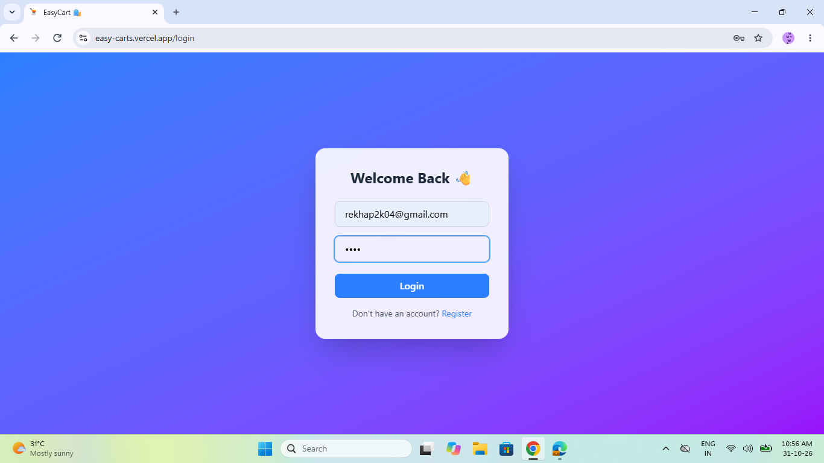
DEF_EC_002 - Home page , product details , shopping cart and checkout issues in pages after browser refresh
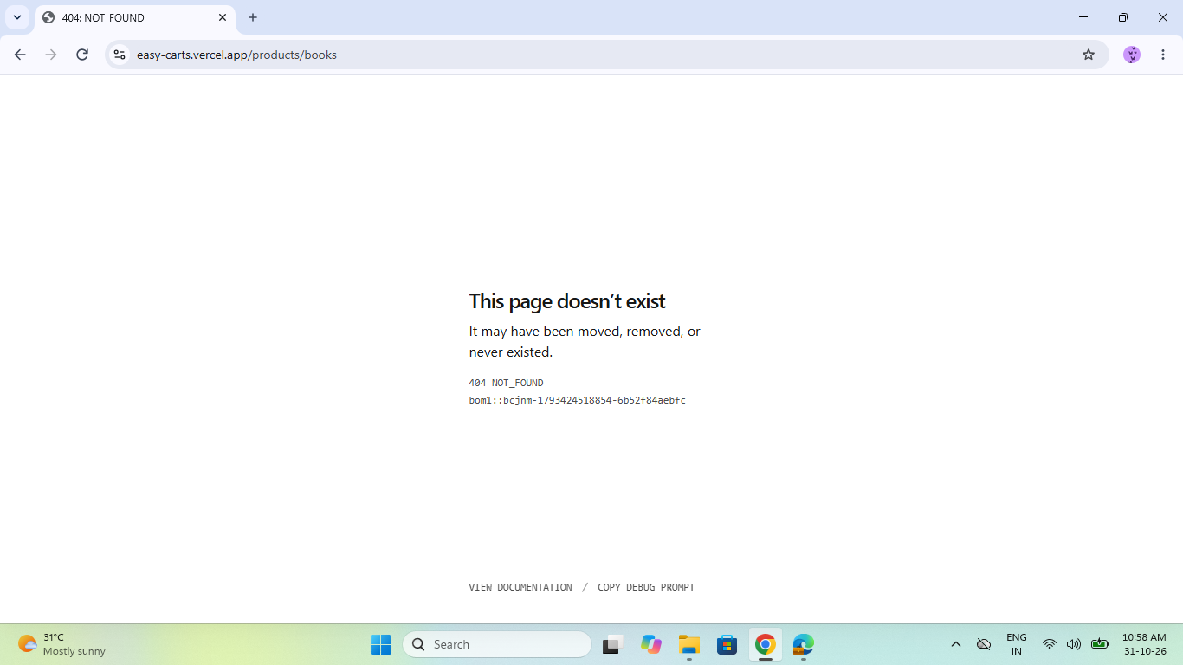

DEF_EC_003 - Product Search Issue
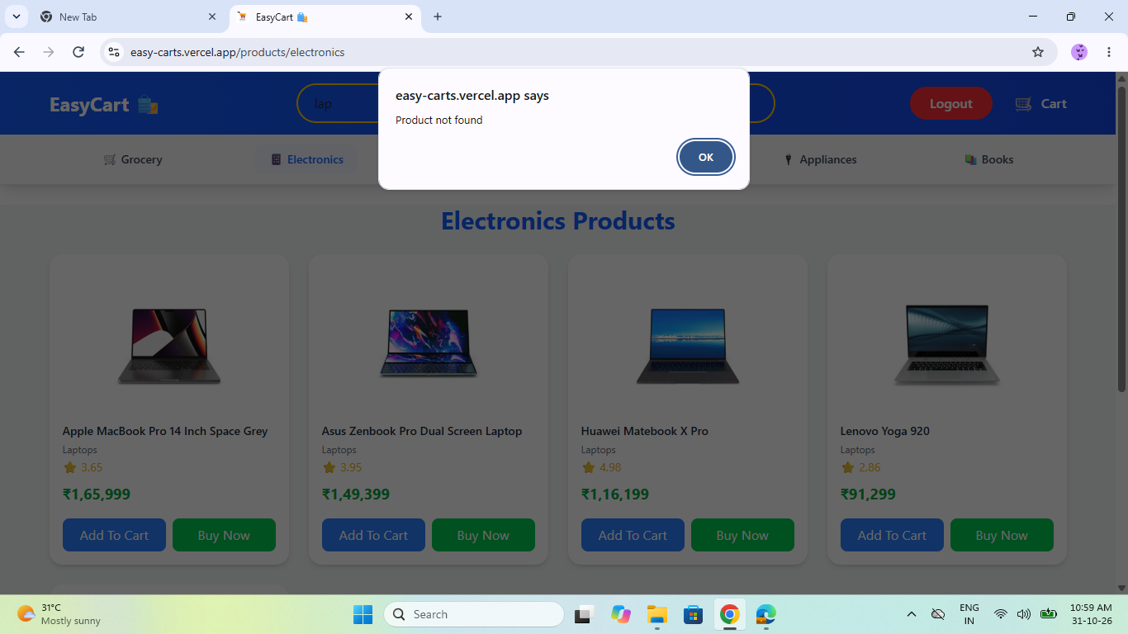

DEF_EC_004 - Address details Issue
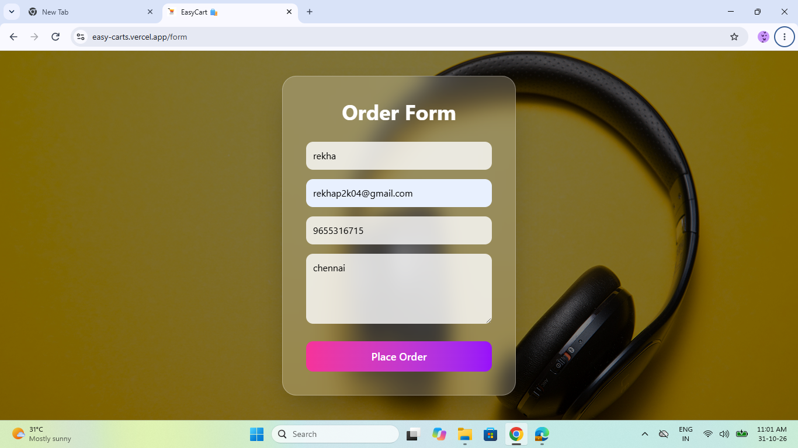
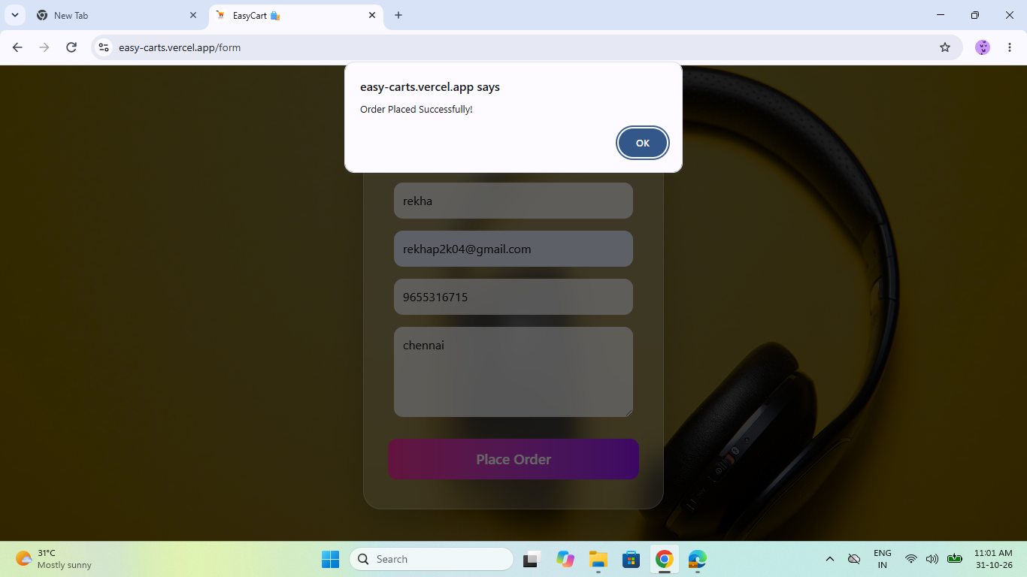

DEF_EC_005 - Postal Code Issue
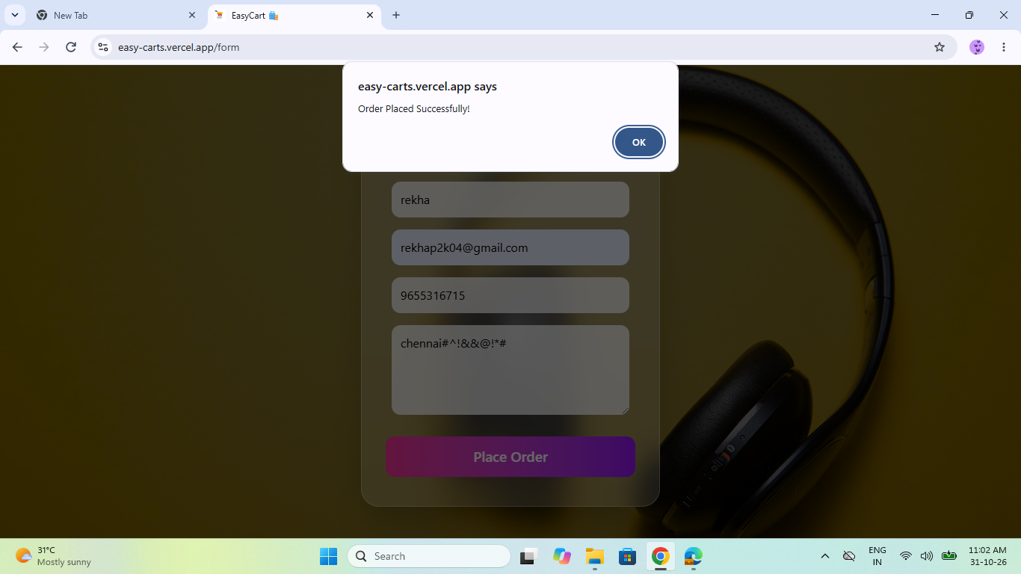
DEF_EC_006 -Mobile number validation Issue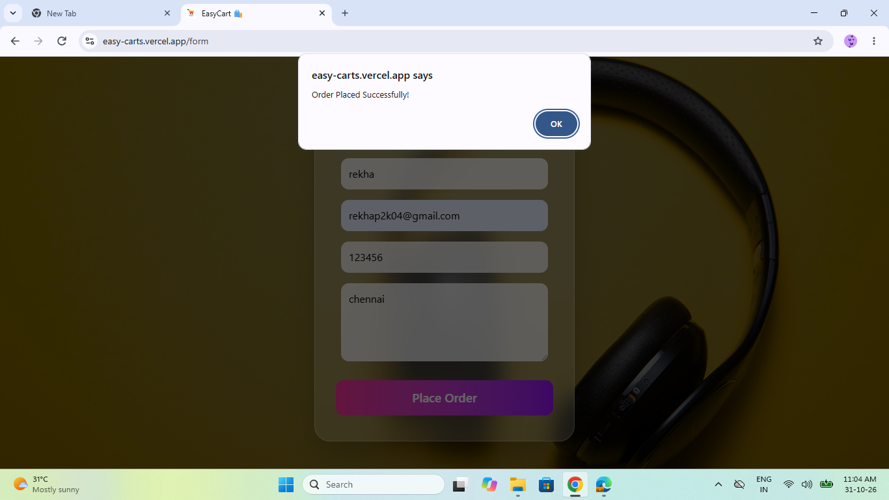
DEF_EC_007 - Email validation Issue
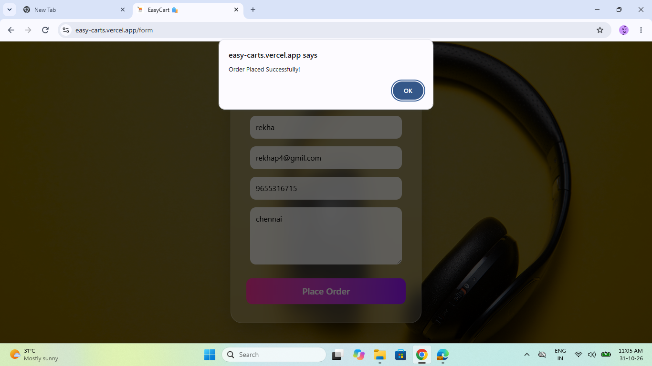
DEF_EC_008 - Cart Total Calculation Issue 

